Mid-Unit 1 Assessment: Life in the Time of the Black Death
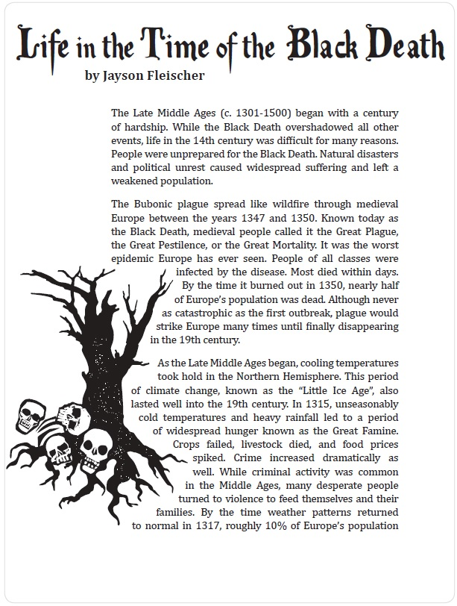
Mid-Unit 1 Assessment: Life in the Time of the Black Death
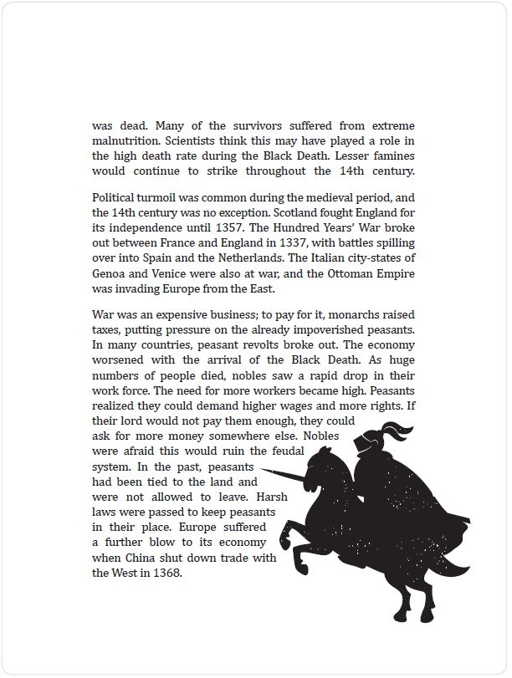
Mid-Unit 1 Assessment: Life in the Time of the Black Death
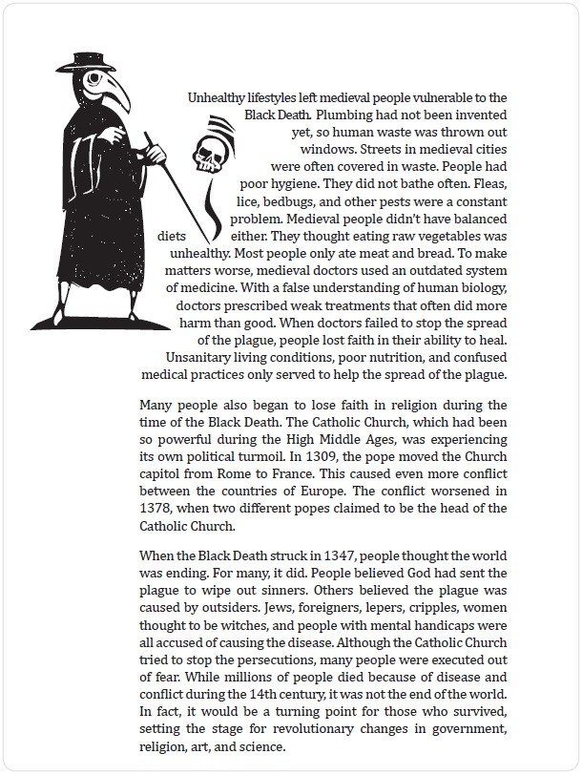
Fleischer, Jayson. "Life in the Time of the Black Death." American Reading Company. 2014: Print.

